**Pizza Project KPI File**

1 the total revenue for the pizza shop

select sum(total_price) as Total_revenue from pizza_sales



2 the average price of the ordder placed by the customer

select sum(total_price) / count(distinct order_id) as avg_order_value from pizza_sales



3 the total number of pizzas sold by the cafe

select sum(quantity) as total_pizzas_sold from pizza_sales



4 the total number of orders placed by the customers over time

select count(distinct order_id) as total_orders_placed from pizza_sales



5 the average amount of pizzas ordered by customers

select cast(cast(sum(quantity) as decimal (10,2)) / cast(count(distinct order_id) as decimal(10,2)) as decimal(10,2)) as avg_pizza_order

from pizza_sales



6 --hourly trend for pizzas sold

select DATEPART(hour, order_time) as order_hour, sum(quantity) as total_pizzas_sold

from pizza_sales

group by DATEPART(hour, order_time)

order by DATEPART(hour, order_time)

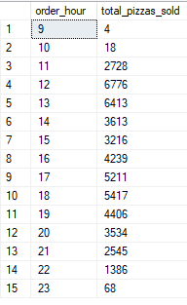

7 --weekely trend for total orders

select DATEPART(ISO_WEEK, order_date) as order_weekely, year(order_date) as year, count(distinct order_id) as total_orders

from pizza_sales

group by DATEPART(ISO_WEEK, order_date),

year(order_date)

order by DATEPART(ISO_WEEK, order_date),

year(order_date)

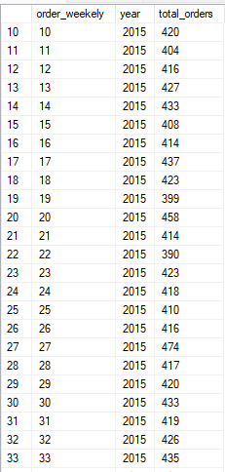 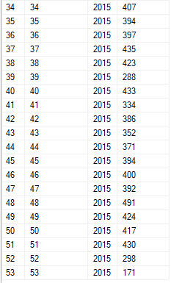

8 --percentage of sales by pizza category and the where clause can be used to filter out the data by month

select pizza_category,sum(total_price) as sales, sum(total_price) * 100 / (select sum(total_price) from pizza_sales where MONTH(order_date) = 1) as Percentage_sales

from pizza_sales

where MONTH(order_date) = 1

group by pizza_category

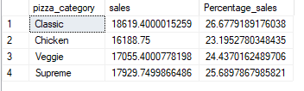

9 percentage of sales by pizza size

select pizza_size,sum(total_price) as total_sales ,cast(sum(total_price) * 100 /(select sum(total_price)from pizza_sales) as decimal (10,2)) as Sales_by_Size_percent

from pizza_sales

group by pizza_size

order by Sales_by_Size_percent desc

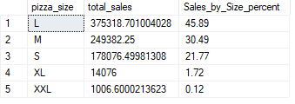

10 we can also find out the sales of pizzas y size in different quarters of the year for more information and further analysis

select pizza_size,sum(total_price) as total_sales ,cast(sum(total_price) * 100 /(select sum(total_price)

from pizza_sales where DATEPART(quarter, order_date) = 1) as decimal (10,2)) as Sales_by_Size_percent

from pizza_sales

where DATEPART(quarter, order_date) = 1

group by pizza_size

order by Sales_by_Size_percent desc

11 top 5 pizzas by revenue

select top 5 pizza_name_id, cast(sum(total_price) as decimal (10,2)) as revenue from pizza_sales

group by pizza_name_id

order by sum(total_price) desc

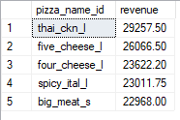

12 bottom 5 pizzas by revenue

select top 5 pizza_name_id, cast(sum(total_price) as decimal (10,2)) as revenue from pizza_sales

group by pizza_name_id

order by sum(total_price)

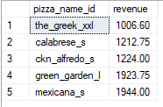

13 top 5 best seller pizzas by quantity

select top 5 pizza_name_id, cast(sum(quantity) as decimal (10,2)) as total_quantity from pizza_sales

group by pizza_name_id

order by sum(quantity) desc

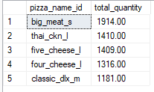

14 worst seller by quantity

select top 5 pizza_name_id, cast(sum(quantity) as decimal (10,2)) as total_quantity from pizza_sales

group by pizza_name_id

order by sum(quantity)

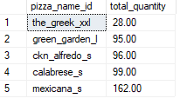

15 top 5 seller based on orders

select top 5 pizza_name_id, count(distinct order_id) as total_orders

from pizza_sales

group by pizza_name_id

order by total_orders desc

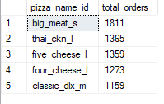

16 worst 5 by orders

select top 5 pizza_name_id, count(distinct order_id) as total_orders

from pizza_sales

group by pizza_name_id

order by total_orders

